- What is the median value of height in the sample? 67
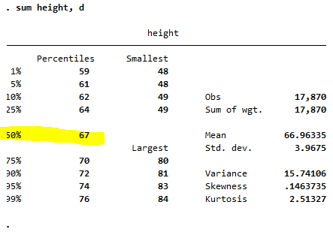
Graph for B:
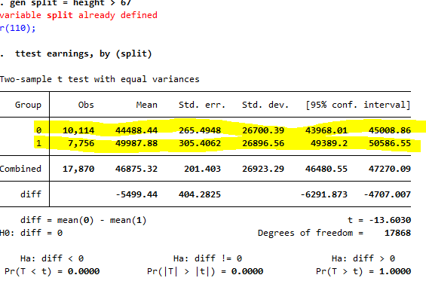
0 = People under 67 inches
1 = People taller than 67 inches

b. Estimate average earnings for workers whose height is at most 67 inches.
$44,488.44
ii. Estimate average earnings for workers whose height is greater than 67 inches.
$49,987.88
iii. On average, do taller workers earn more than shorter workers? How
much more? What is a 95% confidence interval for the difference in average earnings?

Taller workers make an average of $5,499.44 more than shorter workers. The 95% confidence interval for the difference in average earnings is between -6291.873 and -4707.007.

- Construct a scatterplot of annual earnings (Earnings) on height (Height). Notice that the points on the plot fall along horizontal lines. (There are only 23 distinct values of Earnings). Why? (Hint: Carefully read the detailed data description.)

- Run a regression of Earnings on Height.
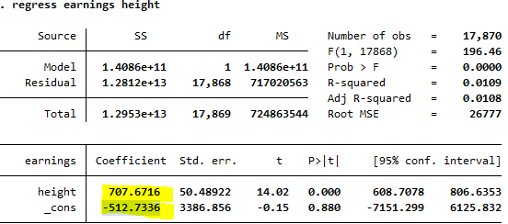
- What is the estimated slope?
Earnings = -512.7336 + 707.6716(HEIGHT)
- Use the estimated regression to predict earnings for a worker who is 67 inches tall, for a worker who is 70 inches tall, and for a worker who is 65 inches tall.
Earnings = -512.7336 + 707.6716(70) = 49024.2784
Earnings = -512.7336 + 707.6716(67) = 46901.2636
Earnings = -512.7336 + 707.6716(65) = 45485.9204

- Suppose height were measured in centimeters instead of inches. Answer the following questions about the Earnings on Height (in cm) regression.

- What is the estimated slope of the regression?
707.6716 (2.54)
ii. What is the estimated intercept?
iii. What is the R2
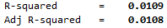
- What is the standard error of the regression?
50.48922(2.54)
- Run a regression of Earnings on Height, using data for female workers only.
Sex == 0 Females
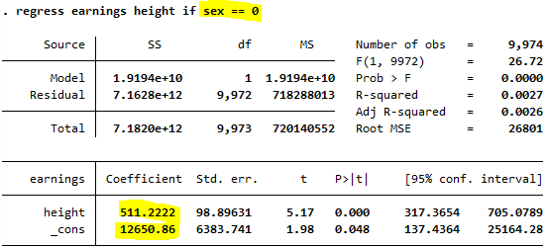
- What is the estimated slope?
FeMale Earnings = 12650.86 + 511.2222(HEIGHT)

- A randomly selected woman is 1 inch taller than the average woman in the sample. Would you predict her earnings to be higher or lower than the average earnings for women in the sample? By how much?
511.2222
g. Repeat (f) for male workers.
Sex == 1 MALE

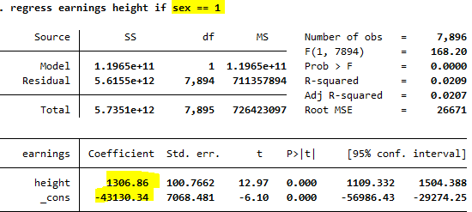
h. Do you think that height is uncorrelated with other factors that cause earning? That is, do you think that the regression error term, ui has a conditional mean of 0 given Height (Xi)? (You will investigate this more in the Earnings and Height exercises in later chapters.)

I don’t think that height is uncorrelated to other independent variables. I think that height can be related to sex because men tend to be taller.
E6.1
a. Regress Birthweight on Smoker. What is the estimated effect of smoking on birth weight?
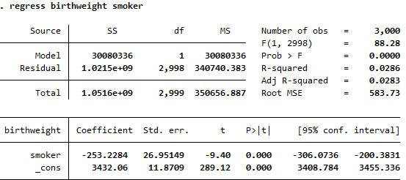
b. Regress Birthweight on Smoker, Alcohol, and Nprevist.
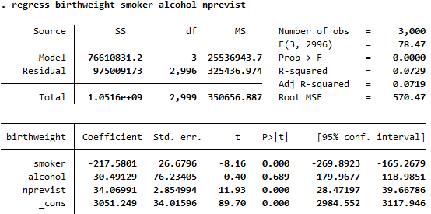
- Using the two conditions in Key Concept 6.1, explain why the exclusion of Alcohol and Nprevist could lead to omitted variable bias in the regression estimated in (a).
Smoking may be correlated with both alcohol and the number of pre-natal doctor visits, thus satisfying (1) in Key Concept 6.1. Moreover, both alcohol consumption and the number of doctor visits may have their own independent affects on birthweight, thus satisfying (2) in Key Concept 6.1.
- Is the estimated effect of smoking on birth weight substantially different from the regression that excludes Alcohol and Nprevist? Does the regression in (a) seem to suffer from omitted variable bias?
The estimated is somewhat smaller: it has fallen to 217 grams from 253 grams, so the regression in (a) may suffer from omitted variable bias.
- Jane smoked during her pregnancy, did not drink alcohol, and had 8 prenatal care visits. Use the regression to predict the birth weight of Jane’s child.
Birthweight = 3051.2 −217.6(1) − 30.5(0) + 34.1(8) = 3106.4
- Compute R2and R2…. Why are they so similar?

R2 = 0.0729 and = 0.0719. They are nearly identical because the sample size is very large (n = 3000).
- How should you interpret the coefficient on Nprevist? Does the coefficient measure a causal effect of prenatal visits on birth weight? If not, what does it measure?
Nprevist is a control variable. It captures, for example, mother's access to healthcare and health. Because Nprevist is a control variable, its coefficient does not have a causal interpretation
c. Estimate the coefficient on Smoking for the multiple regression model in (b), using the three-step process in Appendix 6.3 (the Frisch–Waugh theorem). Verify that the three-step process yields the same estimated coefficient for Smoking as that obtained in (b).
d. An alternative way to control for prenatal visits is to use the binary variables Tripre0 through Tripre3. Regress Birthweight on Smoker, Alcohol, Tripre0, Tripre2, and Tripre3.
Birth Weight = 3454.5 – 228.8(Smoker) – 15.1(Alcohol) – 698(Tripre0) – 100.8(Tripre2) – 137(Tripre3)
i. Why is Tripre1 excluded from the regression? What would happen if you included it in the regression?
Tripre1 is removed to avoid perfect multicollinearity. If we included it in the regression, the regression would not run, because they are an arbitrary normalization.
The estimated coefficient on Tripre0 is large and negative. What does this coefficient measure? Interpret its value.
Pregnant women who did not go to doctor appointments during there pregnancy gave birth to babies who weighed about 698 grams less than women who were pregnant and attended at least one doctor appointment while pregnant.

iii. Interpret the value of the estimated coefficients on Tripre2 and Tripre3.

iv. Does the regression in (d) explain a larger fraction of the variance in birth weight than the regression in (b)?

